**Lab Assignment 4**

Few images are uploaded on LMS. You can use these images for your programs

1. **Image Quantization (Uniform):**

Write your own program in Python/Matlab which works as image quantizer. Take any 8-bit grayscale image as input. Without using any pre-defined function, quantize it into

1. 64 levels (=L)
2. 32 levels
3. 16 levels
4. 4 levels
5. Use direct function in Python or Matlab such as im.quantize in Matlab and match the result with the output of your code in above parts
6. Find the Mean Square Error for parts a)-d). For this, you can take the difference of input and output image which will give you error. Then take square of the error and then mean. Comment on the image quality as you vary L.

Parameters of uniform quantization:

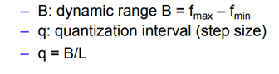

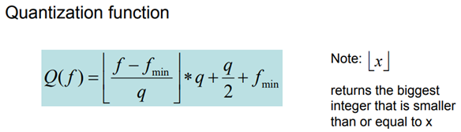

**Example:**

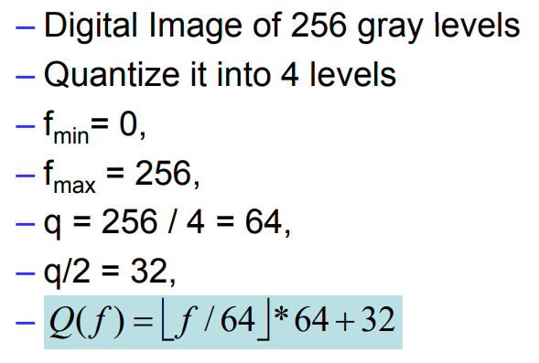

1. **Distance Measures:**

Write a program to compute following distance transforms of the binary image b. First convert grayscale image to binary image. This can be done by setting a threshold such as 0 can be assigned to intensity values <= r and 1 is assigned to intensity values > r where you can choose any value of r from range of intensity values in grayscale image.

1. Euclidean distance
2. City- block distance
3. Chessboard distance
4. **Spatial Operation:**

Write a program to implement spatial domain averaging filter and to observe its blurring effect on the image without using inbuilt functions. Study the effect of applying mean filters of 3x3 5x5, 7x7 on images and compare results